Inglês (3.º Ciclo) / Cidadania e Desenvolvimento
Biografia de Marie Curie
2011 - Ano Internacional da Química

Name _______________________________ Date ____________________________
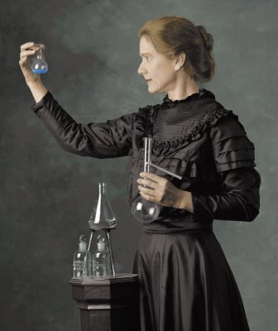
- Read Marie Curie’s biography.
Marie Curie by Susan Marie Frontczak . Retrieved 10/12/2021, from https://www.colorado.edu/cuwizards/susan-marie-frontczak
Marie Curie was born in Poland. She was the youngest of five children. When she was four years old one of her older sisters taught her the alphabet, and Manya (as they called her) learned how to read. Her father was a professor. Her mother was very ill with tuberculosis and died of the disease when Manya was ten years old. When she graduated from high school she won a gold medal because she had been such a good student. Her sister invited her to come to Paris to live and begin her studies. She changed her name to Marie.
At the Sorbonne, the university, she chose to study mathematics and physics. She earned a master's degree and also a doctorate in physics. She met Pierre Curie and they married in 1895. Pierre and Marie began experimenting together and discovered two new radioactive elements, polonium and radium. In 1903 Pierre and Marie along with Henri Becquerel received the Nobel Prize in physics for their work and their discovery of radioactivity. In 1911 she was again awarded the Nobel Prize for discovery of the two new elements polonium and radium.
The Curies had two daughters, Irene and Eve. Pierre was killed when he stepped out in front of a wagon being pulled by horses. Marie was in shock. The University let her start teaching Pierre's classes at the Sorbonne. She was the first woman to teach at the university. Madame Curie made two trips to America to receive a gram of radium each time, first from President Warren Harding and eight years later from President Herbert Hoover. In 1923 the French government gave her a pension of 40,000 francs a year in recognition of her lifetime of work in France. She became ill and died from all her years of exposure to radium. Today doctors identify the disease as leukemia.
Patsy Stevens, “Marie Curie”, Garden of Praise, 2006. Retrieved 10/12/2021, from https://gardenofpraise.com/ibdcurie.htm (adapted and abridged)
- Underline the words in the story as you find them, unscramble them and write them in the boxes below.
ddauraegt
aolPnd
uibrclsotsue
fsorrepso
nobneroS
pyhcssi
ehimatmcast
egniteipmxnre
olpnimuo
uardim
irePre
dyaicoaiitrtv
uriyientsv
vgeemtrnon
nesoipn
MaCeieruri
noinctiroeg
- Complete this crossword puzzle about the text you have just read.
 |  |  |  |  |  |  |  | 1
 | 2
 |  |  |  |  | 3 |  |  |  |  | 4
 | 5
6
 |  |  |  |  |  |  |  |  |  | 7
 |  |  |  |  | 8
9

  Across
  1. | Marie's sister
  5. | Marie and Pierre extracted this from ore.
  6. | was awarded to Marie at graduation
  7. | Marie's daughter who became a nurse
  8. | the cause of Marie's death
  9. | her father's profession
  Down
  1. | her wedding gift to Pierre
  2. | French university
  3. | a disease that affects the lungs
  4. | radioactive element named for Poland

Patsy Stevens, Garden of Praise. Retrieved 10/12/2021, from https://gardenofpraise.com/pdf/scramcurie.pdf.
Patsy Stevens, Garden of Praise. Retrieved 10/12/2021, from https://gardenofpraise.com/pdf/ibdpuz17.pdf.

