ENGLISH WORKSHEET
12TH FORM
TOPIC – WOMEN’S RIGHTS

I
A – You are about to listen to a timeless song whose lyrics were written by James Brown and Betty Jean Newsome. James Brown recorded it on February 16, 1966 in a New York studio and released it as a single later that year. In 2004, this song was ranked number 123 on Rolling Stone magazine's list of the 500 greatest songs of all time. Listen to it in order to replace the wrong words by the correct ones.

It is a man's world, it is a man's world
But it doesn’t mean anything, anything without a woman to care
You see, man created the cars to take us over the world
Man made the planes to carry the heavy load
Man invented electric light to take us out of the dark
Man made the bullet for the war, like Jonas made the ark
It is a man's, man's, man's world
But it doesn't mean anything, anything without a woman to care
Man cares about our little baby girls and our baby boys
Man keeps them happy 'cause man make them toys
And after man does everything, everything he can
You know that man makes money to buy from another man
It is a man's world

But it doesn’t mean anything, anything, not one little thing

without a woman to care
He's lost in the wild
He's lost in sadness

He’s lost, lost and …

James Brown

B – Now answer these questions.

1 - List man’s life enhancing achievements mentioned in the lyrics.
______________________________________________________________________________________________________________________________________________

2 – How important are women in a man’s world? Justify your answer.
______________________________________________________________________________________________________________________________________________

3 - Do you think this song is sexist? Account for your answer.
_____________________________________________________________________________________________________________________________________________________________________________________________________________________

4 – Do we still live in a man’s world? Justify your answer.
______________________________________________________________________________________________________________________________________________
_______________________________________________________________________

5 – Name some of the situations in which women’s rights are not respected.
______________________________________________________________________________________________________________________________________________

C – Find synonyms/antonyms for the following words.

GIVEN WORD | SYNONYM | ANTONYM
1 – transport
2 – weight
3 – wilderness
4 – sweetness
5 – sane

II

A – There are some idioms with the word “man”. Here you have five of them. Match them with their meaning.

1 – to be somebody’s man | a) to show or prove who is brave, skilful, etc. and who is not
2 – to separate the men from the boys | b) with everybody doing or thinking the same thing at the same time
3 – a man’s man | c) to be strong or brave enough
4 – as one man | d) to be the best or the most suitable person to do a particular job
5 – to be man enough | e) a man who is more popular with men than with women

B – Now build two meaningful sentences using two of the idioms above.

1 - _________________________________________________________________
2 - _________________________________________________________________
C – Have a look at these sentences. They all contain idioms with the word “woman” although four of them can also be used with “man”. State their meaning.

SENTENCE | MEANING
1 – I could tell from her address that she was a woman of means.

2 – Despite being the daughter of two Hollywood stars, she’s very much her own woman with her own acting style.

3 – Her research looks at what the woman on the street thinks about gender equality.

4 – You’ve been living with my daughter for two years now, isn’t it time you made an honest woman of her?

5 – She’s a woman of few words. But when she speaks, she makes a lot of sense.

III
A – Recall your general culture or what you’ve learnt in your History lessons. Match the pictures with the names and nationalities and then say what these women have in common. (Images from Wikipedia)
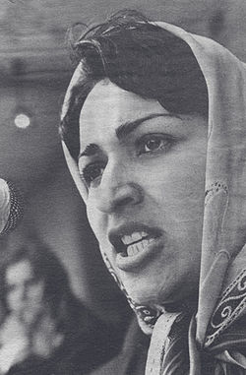
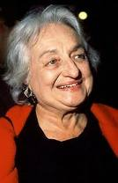
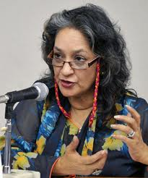
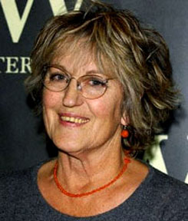
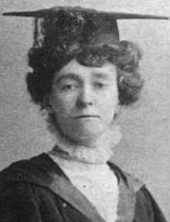
5
4
3
2
1

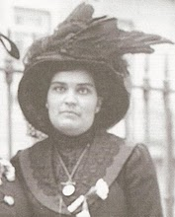
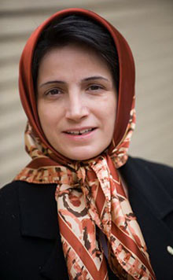
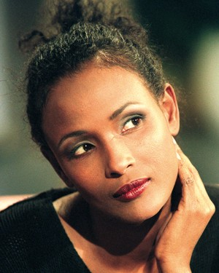
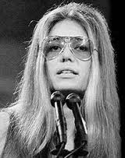
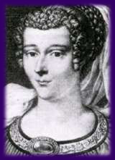
1
10
9
8
7
6

a) Germaine Greer - Australian
b) Emily Davison - English

d) Marie de Gournay - French
c) Meena Kamal - Afghan

f) Nasrin Sotoudeh - Iranian
e) Carolina Ângelo - Portuguese

h) Waris Dirie - Somali
g) Gloria Steinem - American

i) Farida Shaheed - Pakistani
j) Betty Friedan - American

1 | 2 | 3 | 4 | 5 | 6 | 7 | 8 | 9 | 10

B – Now say which of them:
1– fought for female suffrage at the beginning of the 20th century. _______________
2– was assassinated in 1987 when she was only 30. __________
3– has been fighting for the abolition of FGM (female genital mutilation) __________
4– became recognised as a leader of, and media spokeswoman for, the Women’s Liberation Movement in her country in the late 1960s and 1970s. __________
5– is the feminist activist and prominent human rights lawyer that has been imprisoned since September 2010 on charges of spreading propaganda and conspiring to harm state security. __________
6– is the independent expert on cultural rights of the U.N. _________
7– argued that sexual liberation was the key to women’s liberation. __________
8– a leading figure in the Second Wave of the U.S. Women’s Movement. __________
9– defended the equality of man and women in the 17th century . __________
10– was the first woman who managed to vote within the twelve countries that first composed the European Union. __________

Adapted from Cristina Ramalho, ESCOLA SECUNDÁRIA DE CASQUILHOS

